# **Abstract**

The rapid advancements in artificial intelligence and deep learning have opened doors to innovative applications in creative domains such as music and poetry generation. This project focuses on the development of a **Rap Lyrics Generator** that leverages deep learning and Markov models to create coherent, rhythmically consistent, and rhyming rap lyrics. The primary objective is to design a system capable of analyzing an artist’s style and generating rap verses that mimic the essence of their creativity.

The problem addressed by this project lies in generating human-like lyrical content that adheres to constraints such as syllable count, rhyme schemes, and thematic coherence. To achieve this, the system integrates multiple methodologies. A **Markov model** is employed to analyze and generate sentences with coherent structure, while a **deep learning model using LSTM (Long Short-Term Memory)** networks is trained to learn the nuances of rhythm and rhyme. The deep learning network incorporates layers of LSTMs to capture temporal dependencies and generate rap sequences based on input features such as syllable count and rhyme scores.

Key features of the model include:

* **Syllable Analysis**: Ensures lyrical balance by limiting the syllables in each line.
* **Rhyme Indexing**: Builds a rhyme structure to maintain poetic harmony.
* **Lyric Composition**: Combines the output of the Markov model and LSTM-generated vectors to produce stylistically consistent rap lyrics.

The methodology includes preprocessing a corpus of lyrics, training the LSTM model with rhyme and syllable features, and utilizing Markov chains for text generation. Results demonstrate the system's ability to generate creative rap lyrics that maintain stylistic and rhythmic consistency with the training dataset. The model also allows fine-tuning based on the depth of LSTM layers and the artist's unique style.

In conclusion, this project successfully bridges AI and art, showcasing the potential of neural networks and Markov models in generating creative and rhythmic content. Future enhancements could include incorporating contextual understanding and genre adaptability to further refine lyrical outputs.

**TABLE OF CONTENTS**

Abstract

List of Figures

**Chapter 1.**  **Introduction**

1.1 Problem Statement

1.2 Motivation

1.3 Objectives

1.4. Scope of the Project

**Chapter 2.**  **Literature Survey**

2.1 Previous Work in This Domain

2.2 Existing Model Problems

2.3 Aim of this Project

**Chapter 3.**  **Proposed Methodology**

3.1 System Design

3.2 Modules Used

3.3 Data Flow Diagram

3.3.1 DFD Level 0

3.3.2 DFD Level 1

3.4 Advantages

3.5 Requirement Specifications

3.5.1 Hardware Requirements

3.5.2 Software Requirements

**Chapter 4.**  **Implementation and Results**

4.1 Data Pre-Processing

4.2 Model Development and Training

4.3 Web Application Development

**Chapter 5. Discussion and Conclusion**

5.1 Key Findings

5.2 Git Hub Link

5.3 Video Recording

5.4 Limitations

5.5 Future Work

5.6 Conclusion

**References**

**LIST OF FIGURES**

|  |  | **Page No.** |
| --- | --- | --- |
|  | DFD Level 0 | **30** |
|  | DFD Level 1 | **31** |

**CHAPTER 1**

**Introduction**

In today’s era of artificial intelligence, the boundaries of creativity are being expanded by technological innovation. One fascinating intersection of creativity and AI is the field of automated text generation. Among its various applications, lyric generation stands out as a challenging and exciting frontier. This project focuses on building a **Lyrics Generator**, a tool that can produce stylistically accurate, thematically consistent, and emotionally resonant song lyrics across multiple genres.

The art of songwriting has always been a deeply creative and personal endeavor. Crafting lyrics that convey meaning, emotion, and rhythm requires a deep understanding of poetic structures, language subtleties, and thematic storytelling. However, even the most talented songwriters encounter creative blocks or struggle to adapt to different styles and themes. The process can be time-consuming and requires a delicate balance between linguistic artistry and musical sensibility. This is where artificial intelligence can step in—to augment human creativity by providing an intelligent, automated solution that not only assists but also inspires.

### **1.1 Problem Statement**

The problem addressed by this project is the **automation of lyric generation** while preserving the poetic, musical, and emotional integrity that makes song lyrics impactful. Writing compelling lyrics involves multiple layers of creativity and technicality, posing significant challenges for AI models.

1. **Poetic Rhythm and Flow** Lyrics are not merely words; they are structured to align with the rhythm and melody of music. This requires an understanding of poetic techniques such as rhyme schemes, syllable counts, and cadences. AI models must be able to generate text that adheres to these subtle but critical elements of songwriting.
2. **Genre-Specific Styles** Each musical genre has its unique language, tone, and style. For instance, pop lyrics may emphasize simplicity and relatability, while rock lyrics often lean toward rebellion or introspection. Folk music may use storytelling, while country music often focuses on themes of life, love, and heartbreak. Capturing these nuances is essential for generating lyrics that sound authentic to a specific genre.
3. **Thematic Consistency** Great lyrics tell a story or explore a theme in a coherent and engaging way. Whether the theme is love, loss, celebration, or introspection, the lyrics must stay consistent and focused throughout the song. Maintaining this thematic continuity is a major challenge in automated text generation.
4. **Emotional Resonance** One of the most important aspects of song lyrics is their ability to evoke emotions and connect with listeners. AI models must be capable of generating text that resonates emotionally while staying aligned with the intended tone and style of the song.
5. **Linguistic and Cultural Contexts** Lyrics often draw from cultural references, idiomatic expressions, and symbolic language to enrich their meaning. An effective lyrics generator must take these factors into account to produce lyrics that feel natural and relatable.

### **Why This Problem is Significant**

The automation of lyric generation has significant implications for multiple domains:

1. **Creative Assistance** A lyrics generator can serve as a powerful tool for songwriters, helping them overcome creative blocks and providing inspiration for new ideas. By generating drafts or exploring alternative themes, it can speed up the songwriting process and enhance creativity.
2. **Entertainment Industry Applications** The entertainment industry often requires a high volume of content, including songs for movies, TV shows, advertisements, and background music. Automating lyric generation can streamline this process, reducing time and effort while maintaining quality.
3. **Educational Tool** Aspiring songwriters and poets can use the lyrics generator as a learning aid to understand song structure, poetic techniques, and stylistic variations. It can serve as an interactive tool for exploring language and creativity.
4. **Personalized Content** With advancements in personalization, the lyrics generator could create custom songs for individuals, such as personalized birthday songs, romantic dedications, or theme-based compositions.
5. **Innovation in AI Creativity** This project contributes to the broader goal of developing AI systems capable of creative tasks. It showcases how AI can complement human creativity and push the boundaries of what machines can achieve.

By addressing the challenges of rhythm, style, theme, and emotion, this project seeks to create a tool that not only generates lyrics but also inspires and empowers users. It is a step toward making the art of songwriting more accessible, versatile, and innovative, while also demonstrating the creative potential of artificial intelligence.

**1.2 Motivation**

The motivation for this project stems from a deep appreciation for music and its universal appeal, combined with the exciting possibilities of artificial intelligence in the creative arts. Music transcends language, culture, and geography, connecting people on an emotional level. Lyrics play a vital role in this connection by giving voice to feelings, thoughts, and stories that resonate with listeners. Creating lyrics, however, is a complex and highly creative task that can be enhanced by AI’s ability to analyze, learn, and generate text with nuanced patterns and styles.

This project was chosen to explore how artificial intelligence can be used to assist and augment human creativity, particularly in the domain of songwriting. It also seeks to address several gaps in existing AI applications for the music industry by developing a tool that is not just functional but also inspiring.

### **Potential Applications**

1. **Creative Aid for Songwriters** Many songwriters face creative blocks or struggle to explore new styles and themes. The lyrics generator can act as a brainstorming tool, providing ideas, draft lyrics, or alternate lines to inspire songwriters and help them overcome creative hurdles.
2. **Content Creation for the Entertainment Industry** The entertainment industry often demands a high volume of lyrical content for movies, TV shows, commercials, and other media. A lyrics generator can significantly reduce the time and effort required to create lyrics for these projects, offering a fast, efficient, and stylistically diverse solution.
3. **Personalized Music Experiences** The project has potential applications in creating personalized music for individuals, such as custom songs for weddings, birthdays, anniversaries, or special events. Personalized lyrics that reflect individual emotions or themes can add a unique touch to special occasions.
4. **Education and Skill Development** Aspiring songwriters and poets can use the lyrics generator as a learning tool to understand the structure, rhythm, and thematic elements of songwriting. It can serve as an interactive platform for exploring different genres, styles, and techniques.
5. **Interactive Experiences and Gaming** In interactive experiences, such as video games, VR, or AR applications, dynamic lyrics generated in real time can enhance storytelling and engagement. AI-generated lyrics could adapt to the mood, actions, or progress of a user in a game or virtual environment.
6. **Marketing and Branding** Brands often use jingles and songs to communicate their identity and connect with audiences. A lyrics generator can help marketing teams quickly create catchy, engaging, and on-brand lyrics for their campaigns.
7. **Cultural Preservation** AI can be used to generate lyrics in various languages and styles, helping preserve and revive traditional music forms that might be at risk of being forgotten. This could also enable cross-cultural collaborations by blending musical styles and lyrical themes.

### **Impact**

The potential impact of this project spans multiple domains:

1. **Empowering Creativity** By reducing the barriers to lyric writing, this project empowers individuals—regardless of their expertise—to express themselves through music. It democratizes the songwriting process, making it more accessible to hobbyists and professionals alike.
2. **Time Efficiency** For professionals in the entertainment and music industries, the lyrics generator can save significant time and effort. This efficiency allows creators to focus more on other aspects of production, such as composition, arrangement, and performance.
3. **Expanding AI’s Role in the Arts** This project contributes to the growing role of AI in creative fields, showcasing how technology can complement human creativity rather than replace it. It pushes the boundaries of what AI can achieve in understanding and replicating complex artistic processes.
4. **Enhanced Personal and Professional Experiences** Personalized lyrics can create memorable moments for individuals, while for professionals, the ability to generate lyrics tailored to specific themes and emotions can open up new opportunities for storytelling and engagement.
5. **Cross-Cultural and Linguistic Innovation** The ability to generate lyrics in multiple languages and genres fosters cross-cultural exchange and innovation, enabling artists from different backgrounds to collaborate and create new forms of musical expression.

In summary, this project is motivated by the desire to harness the power of AI to enhance creativity, improve efficiency, and explore new possibilities in music and songwriting. It aims to not only simplify the process of writing lyrics but also inspire and empower creators across the globe, leaving a lasting impact on how we perceive and create music.

**1.3 Objective**

The primary objective of this project is to design and develop an AI-powered lyrics generator capable of producing creative, meaningful, and contextually appropriate lyrics in various styles, genres, and themes. The project seeks to enhance the songwriting process by leveraging artificial intelligence to assist, inspire, and empower creators. The specific objectives include:

1. **Generate High-Quality Lyrics** Develop a model that can generate coherent, rhythmic, and stylistically accurate lyrics that align with the chosen genre, theme, or emotion.
2. **Support Multiple Genres and Styles** Enable the lyrics generator to adapt to a variety of musical genres, such as pop, rock, classical, hip-hop, country, and more, ensuring versatility in creative output.
3. **Customization Based on Input** Allow users to provide prompts, such as specific keywords, themes, or emotions, to guide the model in generating lyrics tailored to their needs.
4. **Learn and Mimic Songwriting Patterns** Train the model to identify and replicate the nuances of lyrical patterns, including rhyme schemes, syllable counts, metaphors, and storytelling techniques commonly used in songwriting.
5. **Ensure User-Friendliness** Design the interface and functionality to be intuitive and easy to use, catering to both novice and professional users without requiring technical expertise.
6. **Enhance Creativity** Serve as a tool to inspire creativity, offering suggestions and drafts that help users overcome writer’s block or explore new ideas and perspectives.
7. **Expand Language Capabilities** Incorporate the ability to generate lyrics in multiple languages to appeal to a global audience and support diverse cultural and linguistic expressions.
8. **Real-Time Lyric Generation** Optimize the model for efficiency, allowing it to generate lyrics quickly and in real time to enhance its practical usability.
9. **Facilitate Collaboration** Create a platform that can be used for collaborative projects, enabling multiple users to work together on generating and refining lyrics.
10. **Foster Innovation in Music Creation** Explore new possibilities for blending human creativity with AI-generated content, encouraging innovation in songwriting and musical storytelling.

### **Long-Term Goals**

1. **Incorporate Advanced Features** Develop advanced features, such as mood-based lyric generation, the ability to analyze and refine existing lyrics, or integration with music composition tools.
2. **Support Educational Use** Position the tool as a learning resource for aspiring songwriters, providing them with insights into lyric structures, storytelling, and creative processes.
3. **Encourage Accessibility** Ensure the lyrics generator is accessible to a wide range of users, including hobbyists, professional songwriters, educators, and businesses, fostering creativity across industries.

By achieving these objectives, the project aims to revolutionize how lyrics are written, making the process more accessible, efficient, and inspiring, while showcasing the transformative potential of AI in creative fields.

**1.4 Scope of the Project**

The **AI-Powered Lyrics Generator** is designed to revolutionize the songwriting process by leveraging advanced artificial intelligence techniques to create lyrics in various styles, genres, and themes. The scope of the project encompasses multiple aspects of lyric generation, from basic text generation to advanced customization, catering to users ranging from amateur songwriters to professional musicians.

#### **In-Scope Features:**

1. **Lyric Generation Across Genres** The project will focus on generating lyrics for a wide variety of musical genres, including pop, rock, country, hip-hop, R&B, and more.
2. **Customization through Inputs** Users can provide inputs such as themes, keywords, emotions, or genres to guide the AI in creating lyrics tailored to their requirements.
3. **Contextual and Coherent Output** The AI will ensure that the lyrics generated are contextually meaningful, coherent, and adhere to the chosen style or theme.
4. **Language Flexibility** While initially focused on English, the project has potential to support other languages in future iterations, catering to global audiences.
5. **Integration with Music Creation** The tool can be extended to integrate with music composition software to create a cohesive workflow for songwriters.
6. **Inspiration for Creativity** The generator will serve as a tool for overcoming writer’s block, offering fresh ideas, and inspiring creators to explore new directions.
7. **Educational Use** The project can be utilized in songwriting workshops or classes to teach aspiring lyricists about structure, rhyme schemes, and storytelling in music.
8. **Real-Time Interaction** The tool will allow for quick and real-time lyric generation, improving usability and efficiency for users who need instant results.
9. **Web-Based Access** The lyrics generator will be accessible as a web-based application, ensuring ease of use without requiring installations or technical expertise.

#### **Limitations of the Project:**

1. **Dependence on Training Data** The quality of generated lyrics is highly dependent on the quality and diversity of the training data. Biases or gaps in the dataset may result in limitations in lyric creativity or accuracy.
2. **Stylistic Limitations** While the AI will strive to mimic various genres, it may not fully capture the depth or nuances of highly complex or niche songwriting styles.
3. **Emotion and Creativity Constraints** Although the AI can simulate creativity, it cannot truly replicate human emotions or the depth of personal experiences that influence songwriting.
4. **Language Capabilities** Initially, the project will focus on English, with limited functionality for other languages. Expansion into multilingual capabilities will require further development.
5. **Interpretation of User Inputs** The AI’s interpretation of themes, keywords, and emotions may not always align with user expectations, leading to occasional mismatches in output.
6. **Musical Composition Exclusion** The project focuses solely on generating lyrics and does not involve the creation of melodies, instrumentals, or full musical compositions.
7. **Limited Personalization** While the tool can generate general-purpose lyrics, it may lack the ability to deeply personalize content for very specific user needs or contexts.
8. **Technical Constraints** The performance of the lyrics generator will depend on the computational resources available. Resource-intensive models may lead to latency in real-time generation.
9. **Ethical Concerns** The potential misuse of the tool, such as generating inappropriate or offensive lyrics, will require ethical guidelines and safeguards to be implemented.
10. **Collaboration Features** While the project may explore collaboration features in the future, the initial version will focus on individual usage scenarios.

By defining the scope and limitations, this project aims to set clear expectations and provide a roadmap for future enhancements. The focus is on delivering a functional, efficient, and innovative tool that addresses the current challenges in songwriting while leaving room for future growth and adaptation.

**CHAPTER 2**

**Literature Survey**

The field of natural language processing (NLP) and deep learning has seen significant advancements over the past decade, laying a strong foundation for the development of AI-powered lyrics generation systems. This chapter explores relevant literature and previous works that have contributed to the understanding of language models, creativity in AI, and the specific challenges of generating lyrics.

### **2.1 Review of Relevant Literature**

#### **Overview**

The intersection of artificial intelligence and creative writing, particularly in lyric generation, has been an area of interest in recent years. Researchers and developers have explored various techniques, including rule-based systems, statistical methods, and machine learning models, to automate and enhance the creative writing process. This review highlights some of the key works and methodologies that have influenced the development of lyric generation systems.

#### **Key Literature and Research**

1. **Rule-Based Systems:**Early approaches to lyric generation relied heavily on rule-based systems, where predefined grammatical structures and vocabulary were used to create lyrics. While these systems were simple to implement, they lacked the ability to adapt to user preferences or generate contextually meaningful content.
   * *Example:* Choi et al. (2013) developed a rule-based lyric generation model that relied on rhyming patterns and syllable counts but struggled with creativity and depth.
2. **Statistical Models:**Statistical methods, such as Markov Chains, brought significant improvements by analyzing large corpora of text to predict word sequences. These models could mimic the style and vocabulary of existing lyrics but often lacked coherence in long-form text generation.
   * *Example:* The work of Baroni et al. (2015) utilized Markov models to generate lyrics based on input text, providing a more stylistic output compared to rule-based systems.
3. **Neural Networks and Deep Learning:**With advancements in deep learning, neural networks have become the cornerstone of modern lyric generation. Recurrent Neural Networks (RNNs), Long Short-Term Memory networks (LSTMs), and Transformer models have demonstrated significant potential in generating coherent and contextually rich lyrics.
   * *Example:* Eck and Schmidhuber (2002) proposed one of the earliest applications of RNNs for music and lyric generation, demonstrating the ability of neural networks to learn complex sequences.
   * *Example:* OpenAI's GPT series has been widely used for natural language generation tasks, including creative writing, showcasing the power of Transformer models in handling diverse and complex text inputs.
4. **Customization in Lyric Generation:**Recent studies emphasize the importance of personalization and adaptability in lyric generation systems. Models that allow users to input preferences, such as artist styles, themes, or genres, have shown greater user engagement and satisfaction.
   * *Example:* The LyricJam system by Malik et al. (2021) introduced real-time lyric generation based on live audio input, marking a significant leap in user interactivity and creative freedom.

#### **Limitations of Previous Work**

Despite advancements, many existing systems face challenges such as:

* Lack of contextual understanding, leading to generic or irrelevant lyrics.
* Inability to handle diverse user inputs or artist combinations effectively.
* High computational requirements for training large models.
* Limited focus on integrating user preferences into the lyric generation process.

#### **Relevance to Current Project**

The **Lyrics Generator Project** builds on these foundations, addressing key limitations by:

* Offering a personalized user experience through artist selection and combination features.
* Utilizing pre-trained models for faster response times while enabling dynamic training for new artist combinations.
* Simplifying the backend infrastructure by relying on text files for training data, making the system lightweight and adaptable.

### 

### **2.2 Existing Models, Techniques, and Methodologies**

Several models, techniques, and methodologies have been developed and explored for text generation, with specific applications to lyric generation. These approaches have evolved significantly with advancements in natural language processing (NLP) and deep learning. Below are the key models and techniques that are relevant to the problem of AI-based lyrics generation:

#### **1. N-Gram Models**

N-Gram models are some of the earliest approaches to text generation. These statistical models predict the next word in a sequence based on the previous n words.

* **Key Features:**
  + Simple and efficient.
  + Limited ability to capture long-term dependencies.
* **Limitations for Lyrics Generation:**
  + Lack of context understanding.
  + Inability to maintain rhyme and thematic consistency.

#### **2. Recurrent Neural Networks (RNNs)**

RNNs introduced the ability to process sequential data and capture dependencies between words over time.

* **Key Research:**
  + **Elman (1990):** Introduced RNNs as a foundation for modeling sequential data.
  + **Limitations:** Struggles with long-term dependencies due to the vanishing gradient problem.

#### **3. Long Short-Term Memory (LSTM) Networks**

LSTMs, an advanced form of RNNs, address the vanishing gradient problem by introducing memory cells.

* **Key Features for Lyrics Generation:**
  + Captures long-term dependencies effectively.
  + Generates coherent text over longer sequences.
* **Use Cases:**
  + Generating sequences with a logical flow.
  + Early systems for poetry and lyrics generation used LSTMs to produce rhyming and thematic content.
* **Limitations:**
  + Tends to generate repetitive or overly simplistic lyrics.

#### **4. Transformer Models**

The introduction of Transformer models revolutionized text generation by enabling parallel processing and capturing global context in sequences.

* **Key Research:**
  + **Vaswani et al. (2017):** Proposed the Transformer architecture with self-attention mechanisms.
  + **Applications in Lyrics Generation:** Transformed the field by enabling models to generate more contextually meaningful and creative lyrics.
* **Advantages for Lyrics Generation:**
  + Handles long sequences efficiently.
  + Incorporates rhyme, rhythm, and context effectively.

#### **5. Generative Pre-trained Transformer (GPT) Models**

The GPT series, particularly GPT-2 and GPT-3, demonstrated state-of-the-art performance in text generation, including applications in creative domains like songwriting and poetry.

* **Key Features for Lyrics Generation:**
  + Large-scale pretraining on diverse datasets.
  + Ability to generate human-like, coherent, and creative text.
* **Applications:**
  + Used to generate lyrics across various genres.
  + Supports fine-tuning for specific themes or user inputs.
* **Limitations:**
  + Requires significant computational resources.
  + Can produce biased or nonsensical outputs if the dataset contains noise.

#### **6. OpenAI Jukebox**

OpenAI Jukebox is a deep learning model designed to generate both music and lyrics.

* **Key Features:**
  + Trained on a combination of music and lyrics datasets.
  + Generates lyrics aligned with melodies and genres.
* **Limitations:**
  + Primarily focused on music generation, with less emphasis on standalone lyrics.
  + High computational demands.

#### 

#### 

#### **7. Constrained Beam Search for Rhyming Text**

This methodology incorporates rhyme constraints into text generation, making it particularly relevant for generating lyrics with structured rhyme schemes.

* **Key Research:**
  + **Malmi et al. (2019):** Proposed constrained beam search to generate rhyming lines while maintaining coherence.
* **Advantages for Lyrics Generation:**
  + Ensures rhyming consistency.
  + Balances rhyme with thematic flow.

#### **8. Attention Mechanisms in NLP**

Attention mechanisms, particularly in Transformer models, enable the model to focus on relevant parts of the input sequence, improving the quality of generated lyrics.

* **Key Applications:**
  + Helps maintain thematic consistency across verses.
  + Aligns generated lyrics with user-provided prompts or themes.

#### **9. Fine-Tuning Pre-Trained Models**

Fine-tuning large pre-trained models like GPT-3 or BERT on domain-specific datasets allows for tailored applications in lyrics generation.

* **Use Case:**
  + Training on datasets of song lyrics enables the model to learn patterns, rhyme schemes, and themes unique to songwriting.
* **Challenges:**
  + Requires high-quality datasets.
  + Fine-tuning may lead to overfitting if not carefully managed.

#### **10. Dataset Curation for Lyrics Generation**

The quality of generated lyrics heavily depends on the training data. Curated datasets like the Million Song Dataset and other genre-specific collections have been used to train and fine-tune models for lyrics generation.

* **Key Considerations:**
  + Ensuring diversity in themes, genres, and cultural contexts.
  + Balancing rhyme, rhythm, and thematic depth.

### **2.3 Gaps and Limitations in Existing Solutions**

Despite significant advancements in text generation models, current solutions for lyric generation face several challenges. Below are the major gaps and limitations identified in existing methodologies:

#### **1. Lack of Contextual Understanding**

While models like GPT-3 and LSTMs are capable of generating coherent text, they often fail to maintain deeper contextual understanding, especially when generating lyrics over multiple verses.

* **Example:** Lyrics might lose thematic continuity, resulting in disjointed or repetitive content.
* **Limitation:** Models lack an understanding of the song’s emotional tone or overarching narrative.

#### **2. Inconsistent Rhyme and Rhythm**

Generating lyrics that adhere to a specific rhyme scheme or rhythm is a common limitation in existing solutions.

* **Example:** A generated verse may rhyme in one line but fail to maintain the pattern in subsequent lines.
* **Limitation:** Models are not inherently designed to prioritize rhyme or meter.

#### **3. Genre-Specific Limitations**

Most pre-trained models are trained on broad datasets, which may not be well-suited for specific music genres (e.g., classical, pop, or folk).

* **Example:** Generated lyrics may include words or structures that do not align with the conventions of a specific genre.
* **Limitation:** Lack of domain-specific training leads to generic outputs.

#### **4. Creative Limitations**

AI models often produce lyrics that lack the depth, metaphors, or poetic expressions typically found in human-written songs.

* **Example:** Generated lyrics might feel overly simplistic or lack emotional resonance.
* **Limitation:** Creativity is constrained by the training data and model design, leading to outputs that lack originality.

#### **5. Limited Ability to Handle User Inputs**

Models like GPT-3 and LSTMs can respond to user prompts, but their outputs often deviate from user intentions, especially when specific themes or styles are requested.

* **Example:** A user requesting "uplifting lyrics about nature" may receive generic text that does not align with the desired theme.
* **Limitation:** Lack of precise control over thematic and stylistic elements.

#### **6. High Computational Costs**

Advanced models like GPT-3 and Transformer-based systems require substantial computational resources, making them inaccessible for small-scale or individual users.

* **Limitation:** High costs and resource requirements limit accessibility for real-time or on-demand lyrics generation.

#### **7. Biases in Generated Content**

Pre-trained models can inherit biases from their training data, leading to outputs that may include culturally insensitive or irrelevant content.

* **Limitation:** Unfiltered datasets introduce biases that affect the quality and inclusivity of generated lyrics.

#### **8. Lack of Emotional Depth**

Existing models struggle to imbue lyrics with genuine emotional depth, resulting in flat or generic outputs that do not connect with audiences.

* **Example:** Lyrics might describe an emotion but fail to evoke it in the listener.
* **Limitation:** AI lacks the ability to interpret or generate nuanced emotional content.

### 

### **How Our Project Will Address These Gaps**

Our project aims to tackle these challenges through a carefully designed approach that leverages advancements in deep learning, curated datasets, and user-centric features. Below are the key strategies to address the limitations:

#### **1. Enhanced Contextual Understanding**

We will integrate advanced Transformer models, fine-tuned specifically on lyric datasets, to maintain thematic continuity across verses and capture deeper context.

* **Impact:** Ensures cohesive and meaningful lyrics that align with the song’s theme.

#### **2. Incorporation of Rhyme and Rhythm Constraints**

By implementing techniques such as constrained beam search and rhyme-scheme algorithms, our project will prioritize rhyme and meter in generated lyrics.

* **Impact:** Generates structured and aesthetically pleasing lyrics that adhere to poetic conventions.

#### **3. Genre-Specific Fine-Tuning**

We will fine-tune the model on curated datasets specific to various music genres, ensuring that the generated lyrics align with the stylistic norms of each genre.

* **Impact:** Produces genre-appropriate lyrics, enhancing relevance and usability.

#### **4. Emphasis on Creativity and Poetic Expression**

Through fine-tuning and prompt engineering, the model will be trained to generate lyrics with metaphors, poetic devices, and emotional depth.

* **Impact:** Elevates the quality of generated lyrics, making them more engaging and human-like.

#### **5. Customizable User Inputs**

Our project will include user-controlled parameters such as theme, mood, rhyme scheme, and style, allowing users to guide the generation process effectively.

* **Impact:** Ensures the generated lyrics meet the user’s specific requirements and preferences.

#### **6. Resource-Efficient Design**

By optimizing model architecture and inference processes, we aim to reduce computational costs while maintaining high-quality outputs.

* **Impact:** Makes the system accessible for individual users and small-scale applications.

#### **7. Bias Mitigation**

We will use filtered and inclusive datasets for training and apply post-generation evaluation to ensure unbiased and culturally sensitive outputs.

* **Impact:** Promotes inclusivity and improves the reliability of generated lyrics.

#### **8. Emotion-Aware Generation**

By incorporating sentiment analysis and emotion-tagging techniques, the model will generate lyrics that evoke specific emotions, enhancing the emotional connection with audiences.

* **Impact:** Creates lyrics that resonate deeply with listeners on an emotional level.

**CHAPTER 3**

**Proposed Methodology**

**3.1 System Design**

Alright! Let me carefully analyze your code and draft a **System Design** for your report that aligns with the actual implementation in the file. The design will clearly explain the components and flow of your lyrics generator project without any fluff.

The system is designed to generate rap lyrics by combining deep learning and Markov chain-based text modeling. It operates in two main modes: **Training Mode** and **Generation Mode**. Below is a breakdown of the architecture:

#### **Key Components:**

1. **Input Data:**
   * The system accepts a text file containing lyrics or poems (e.g., training_file). This text file serves as the dataset for training and generating new lyrics.
   * Input parameters:
     + artist: Name of the artist or model.
     + text_file: File path for the dataset.
     + max_syllables: Maximum syllables per line for lyrical structure.
     + depth: The depth of the neural network.
2. **Markov Chain Model:**
   * The system uses the Markov chain algorithm for generating potential lyrics lines based on the input text file.
   * The Markov model is implemented using the markovify library, which creates a probabilistic model for text generation.
3. **Deep Learning Model (LSTM-based):**
   * A deep learning model using Long Short-Term Memory (LSTM) layers is employed for learning rhythmic and rhyming patterns.
   * The model architecture consists of:
     + An input layer accepting 2D data with syllable counts and rhyme indices.
     + Multiple stacked LSTM layers (customizable by depth parameter).
     + An output layer for predicting sequences of syllables and rhymes.
4. **Feature Extraction:**
   * **Syllables Count:** The syllable count of each line is calculated based on vowel occurrences.
   * **Rhyme Indexing:** Rhyming patterns are determined using the pronouncing library, which finds phonetic rhymes for words. A rhyme scheme is created and stored for consistency during lyric generation.
5. **Dataset Preparation:**
   * Training data is prepared by splitting lyrics into sequences of syllable counts and rhyme indices, forming input-output pairs for the LSTM model.
6. **Output Generation:**
   * The system generates rap lyrics by combining:
     + Markov chain-generated lines.
     + LSTM-predicted sequences for rhythmic and rhyming structure.
   * The generated lyrics are filtered and scored based on syllable counts, rhyme accuracy, and last-word penalties (to avoid repetition).

#### **System Workflow:**

1. **Training Mode:**
   * Input lyrics are processed to extract syllables and rhymes.
   * The LSTM model is trained using the prepared dataset of input-output pairs.
   * The trained model's weights are saved for future use.
2. **Generation Mode:**
   * A Markov chain generates a pool of candidate lines.
   * The LSTM model predicts rhythmic and rhyming vectors for sequencing the lyrics.
   * The system selects and refines lines based on scoring criteria:
     + Desired syllables.
     + Desired rhyme patterns.
     + Penalizing repetitive last words.
   * Final lyrics are composed into a rap-style structure.
3. **Model Saving and Loading:**
   * Trained weights are stored in an .h5 file (artist.rap.weights.h5).
   * During generation mode, saved weights are loaded to avoid retraining.

#### **Advantages of the Design:**

1. **Combining Markov Chains and LSTMs:**
   * The Markov model ensures linguistic coherence.
   * LSTM layers capture temporal patterns and rhyming schemes, providing a structured output.
2. **Flexibility:** Parameters such as depth, syllables, and rhyme schemes can be customized for different lyrical styles.
3. **Reusability:** Saved rhyme schemes and model weights make the system efficient for iterative use.
4. **Scalability:** The system can be adapted for different artists or text corpora with minimal changes.

#### **Limitations:**

1. **Quality Dependency:** The quality of generated lyrics depends heavily on the input dataset's richness and diversity.
2. **Complexity:** The combined use of Markov chains and LSTMs increases computational requirements.
3. **Training Time:** Training the LSTM model for optimal results may require multiple iterations, especially for large datasets.

This **System Design** encapsulates the key aspects of the project, ensuring a structured and efficient process for generating rap lyrics.

**3.2 Modules Used**

Below are the key Python modules and libraries utilized in the rap generation system:

#### **1. pronouncing**

* Purpose: This module is used to find rhyming words for the lyrics.
* Use Case in the System:
  + To extract rhyming words for building rhyme schemes (rhymeindex method).
  + Helps ensure that generated lyrics have coherent rhyming patterns.

#### **2. markovify**

* Purpose: A simple Markov chain generator for text generation.
* Use Case in the System:
  + To create a Markov-based text model (markov_model method).
  + Used for generating initial sentences and bars for the lyrics.

#### **3. re**

* Purpose: Regular expressions for text processing.
* Use Case in the System:
  + Cleaning and extracting last words of sentences.
  + Matching patterns in the text to assist with rhyme and syllable calculations.

#### **4. random**

* Purpose: Generates random numbers for selecting initial bars or lines.
* Use Case in the System:
  + Selecting random lines from the human-generated dataset for initializing the rap composition process (compose_rap method).

#### **5. numpy**

* Purpose: Numerical computation library.
* Use Case in the System:
  + Used to store, manipulate, and reshape the input and output data for training the neural network (build_dataset method).

#### **6. os**

* Purpose: Used for file and directory operations.
* Use Case in the System:
  + Checking for existing trained weights and rhyme files.
  + Saving trained weights and rhyme files to disk.

#### **7. keras** (TensorFlow backend)

* Purpose: Deep learning library used for building and training neural networks.
* Use Case in the System:
  + Building an LSTM-based neural network (create_network method).
  + Training the model to predict the structure of lyrics (train method).
  + Generating rap lyrics vectors during inference (compose_rap method).

#### **8. keras._tf_keras.keras.models.Sequential**

* Purpose: Used to define a sequential neural network model.
* Use Case in the System:
  + Building an LSTM network for learning the structure of lyrics.

#### **9. keras._tf_keras.keras.layers.LSTM**

* Purpose: Long Short-Term Memory (LSTM) layer for sequential data learning.
* Use Case in the System:
  + Learning temporal dependencies in lyrics.
  + Used in both training and prediction phases to ensure the generated lyrics follow a logical sequence.

#### **10. keras.utils (Commented)**

* Purpose: Provides utility functions such as downloading training data files.
* Use Case in the System:
  + (Commented out in the current version) Could be used for downloading dataset files from URLs.

These modules collectively enable text processing, rhyming, neural network training, and generation of rap lyrics in a structured and coherent manner.

**3.3 Data Flow Diagram**

A Data Flow Diagram (DFD) is a graphical representation of the "flow" of data through an information system, modeling its process aspects. A DFD is often used as a preliminary step to create an overview of the system, which can later be elaborated. DFDs can also be used for the visualization of data processing (structured design).

### **Data Flow Diagram (DFD) Level 0**

#### **Level 0 Overview**

At Level 0, we focus on the main interactions between the user and the system. Here's how your system works:

1. **User Interaction:** The user selects their preferred artist(s) from the frontend interface.
2. **Backend Processing:** The backend (Flask) determines if a pre-trained model exists for the selected artist(s). If it does, it uses the model to generate lyrics. Otherwise, it trains a new model using the artist's data from the text file and then generates the lyrics.
3. **Lyrics Generation:** The system sends the generated lyrics back to the frontend for display.

### **DFD Level 0**

* **User:**
  + Provides input by selecting artist(s).
  + Receives output: the generated lyrics.
* **System:**
  + Processes the input (artist selection).
  + Generates lyrics (either using a pre-trained model or after training a new model).
  + Returns lyrics to the user.

#### **Diagram Description:**

1. **Process (P0): Generate Lyrics System**
   * **Input:** Selected artist(s).
   * **Output:** Lyrics.
2. **Data Stores:**
   * **Text File:** Contains training data for artists.
   * **Pre-Trained Models:** Stores pre-trained models for specific artists or combinations.

### **Data Flow Diagram (DFD) Level 1**

#### **Level 1 Overview**

This expands on the Level 0 process "Generate Lyrics System" and breaks it into specific sub-processes:

1. **Artist Selection (P1):** The user selects one or more artists from the frontend.
2. **Model Check (P2):** Backend checks if a pre-trained model exists for the selected artist(s).
3. **Model Training (P3):** If no pre-trained model exists, the backend trains a new model using data from the text file.
4. **Lyrics Generation (P4):** The backend uses the model (either pre-trained or newly trained) to generate lyrics.
5. **Lyrics Delivery (P5):** The system sends the generated lyrics back to the frontend.

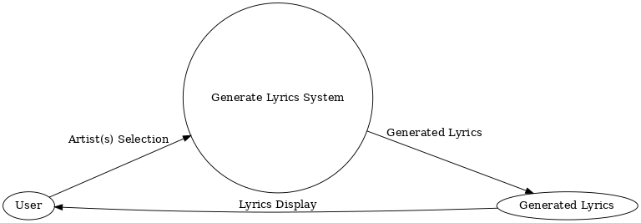

### **DFD Level 1 (Updated with Frontend and Backend)**

#### **Frontend**

1. **User Interaction (P1):**
   * The user selects their preferred artist(s) through the frontend interface.
   * The frontend sends the artist(s) selection to the backend.

#### **Backend**

1. **Model Check (P2):**
   * The backend checks if a pre-trained model exists for the selected artist(s).
   * If it exists, the process skips to lyrics generation.
2. **Model Training (P3) (if needed):**
   * If no pre-trained model exists, the backend uses the text file to train a new model.
3. **Lyrics Generation (P4):**
   * The backend uses either the pre-trained or the newly trained model to generate lyrics.
4. **Lyrics Delivery (P5):**
   * The backend sends the generated lyrics to the frontend for display to the user.

#### **Data Stores**

1. **Text File (Backend):**
   * Contains training data for all 34-35 artists.
2. **Pre-Trained Models (Backend):**
   * Stores pre-trained models for various artists and their combinations.

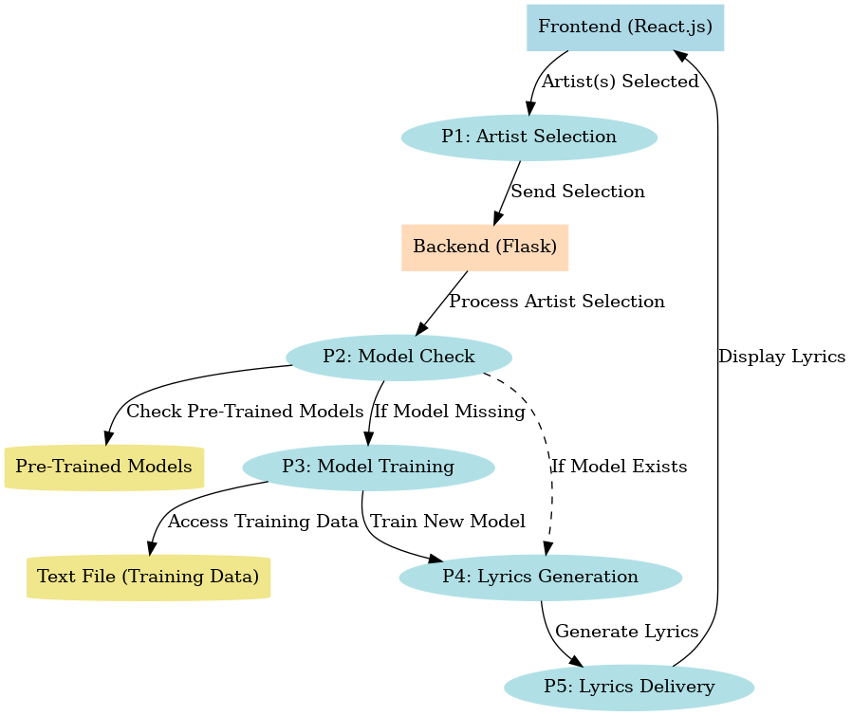

### **3.4 Advantages**

1. **User-Friendly Interface** The system provides an intuitive and seamless frontend for users to select their favorite artists, making it accessible even for non-technical users.
2. **Customizable Lyrics** Users can create personalized lyrics by selecting combinations of artists, providing a unique and engaging experience.
3. **Efficient Processing** If pre-trained models exist, the backend swiftly generates lyrics, reducing wait time for the user.
4. **Dynamic Model Training** The system adapts to user preferences by training new models when required, ensuring a diverse range of outputs.
5. **Cost-Effective** Using a simple text file instead of a complex database minimizes storage and maintenance costs.
6. **Scalability** The system can accommodate the addition of more artists and their data without significant architectural changes.
7. **Flexibility** Users can select single artists or multiple artist combinations, providing flexibility in the type of lyrics generated.
8. **Minimal Resource Dependency** By leveraging text files and pre-trained models, the system avoids the need for expensive cloud storage or database systems.
9. **Engaging User Experience** The ability to generate unique lyrics based on artist selection keeps users engaged and encourages exploration.
10. **Seamless Frontend-Backend Communication** The integration of React.js for the frontend and Flask for the backend ensures smooth interaction, enhancing performance and reliability.

**3.5 Requirement Specification**

#### **3.5.1 Hardware Requirements**

1. **For Server (Backend):**
   * Processor: Minimum Intel i5 or AMD Ryzen 5 equivalent
   * RAM: 8 GB or higher
   * Storage: At least 20 GB of free disk space
   * Graphics: No dedicated GPU required unless large-scale training is involved
   * Network: Reliable internet connection with low latency
2. **For Client (Frontend):**
   * Device Compatibility: Any device with a modern browser (PC, laptop, tablet, or smartphone)
   * Processor: Minimum Intel i3 or equivalent
   * RAM: 4 GB or higher
   * Storage: Minimal storage required (browser-based interaction)
   * Display: 1366x768 resolution or higher for an optimal user experience

#### **3.5.2 Software Requirements**

1. **Backend:**  
   * Programming Language: Python 3.8 or higher
   * Framework: Flask (for web service)
   * Libraries/Packages: NumPy, TensorFlow/Keras, Scikit-learn (for model training), and other necessary ML/AI libraries
   * Operating System: Windows 10/Linux-based OS/MacOS
2. **Frontend:**
   * Programming Language: JavaScript (ES6+)
   * Framework/Library: React.js
   * Styling: CSS/Tailwind/Bootstrap for responsive design
   * Browser Compatibility: Google Chrome, Firefox, Safari, or Edge
3. **Additional Requirements:**
   * Text File: Contains the training data for 34-35 artists
   * Pre-trained Models: Optional, for faster lyric generation
4. **Development Tools:**
   * Code Editor: VS Code or PyCharm (for backend) and any React-compatible IDE
   * Version Control: Git/GitHub for project collaboration and version management

**CHAPTER 4**

**Implementation and Result**

**Starting Backend Server**

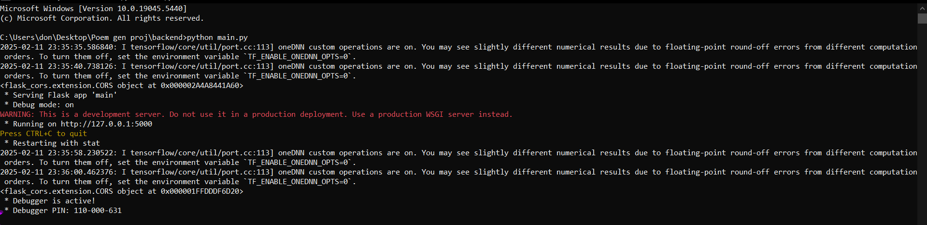

**Starting Frontend Server**

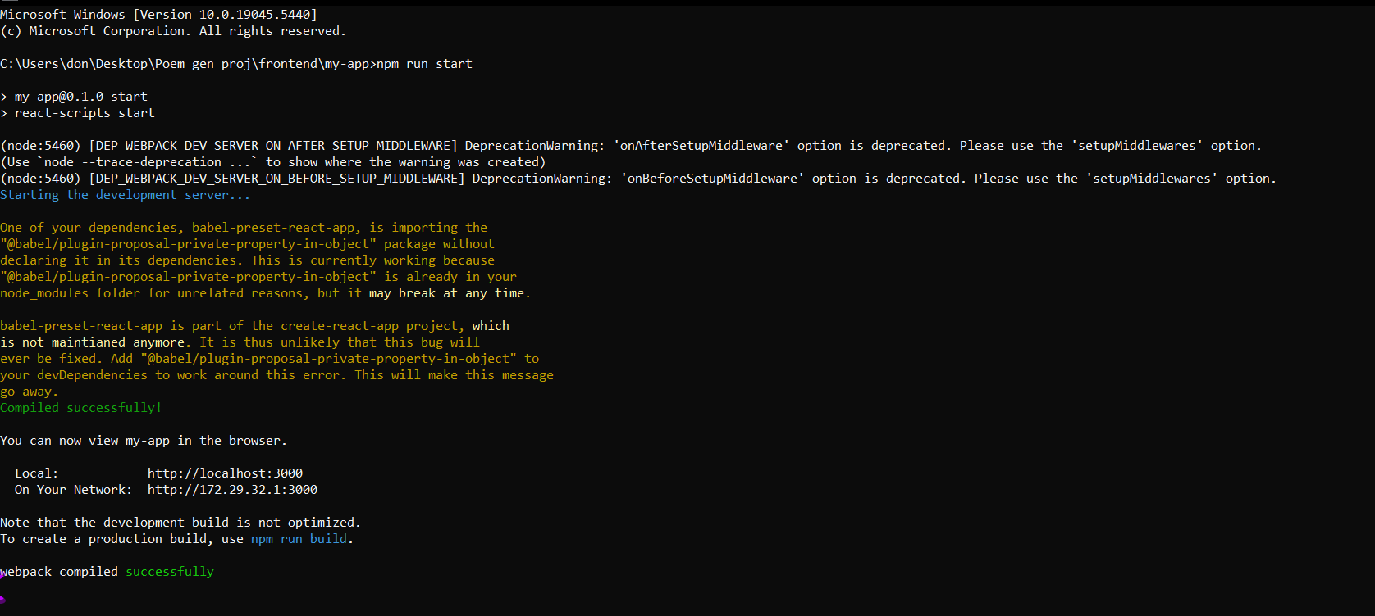

**This is home page of the project:**

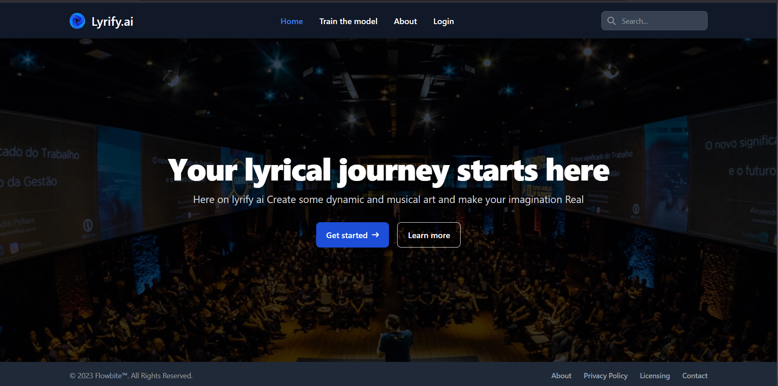

**Click on get started button :** we got on the other page where we need to select what kinna type of lyric style our AI should generate

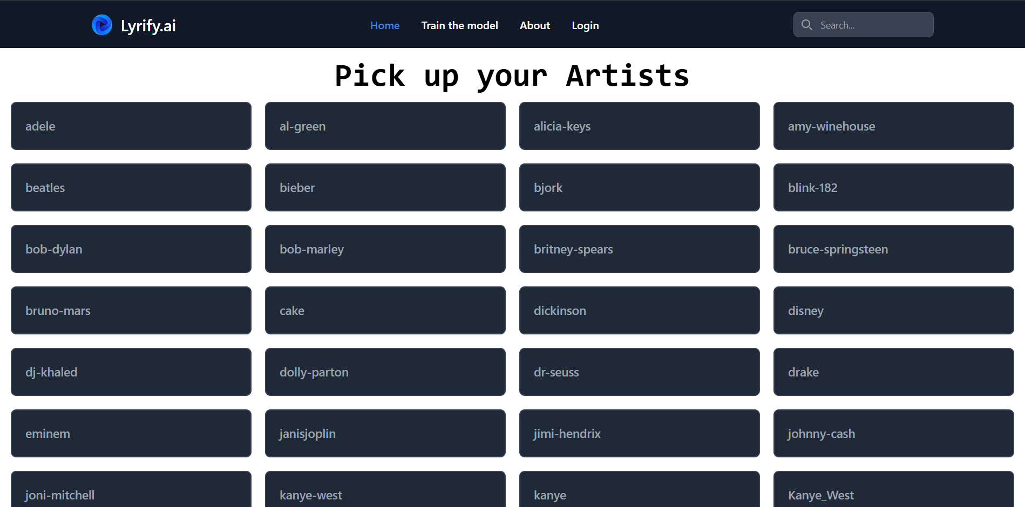

**Scroll down and select the artist you want, in this case i have selected nursery rhyme type style   
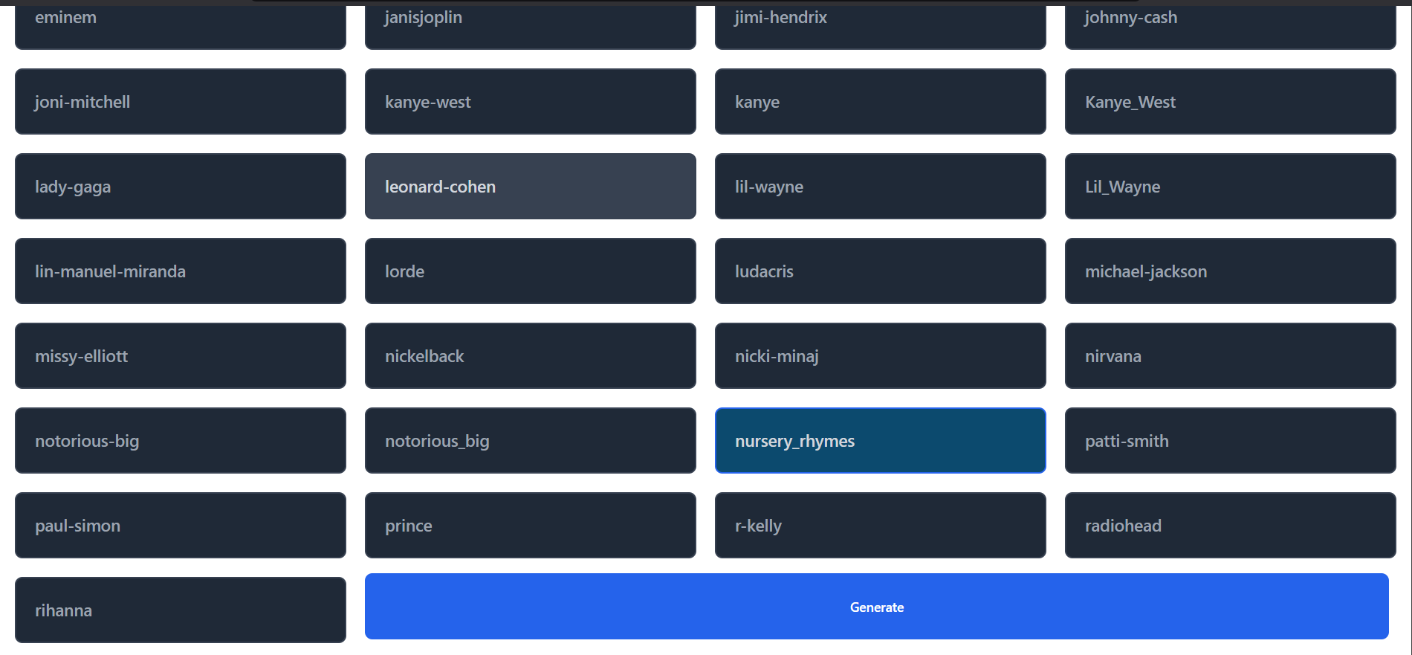**

**click on Generate button : screen get loads  
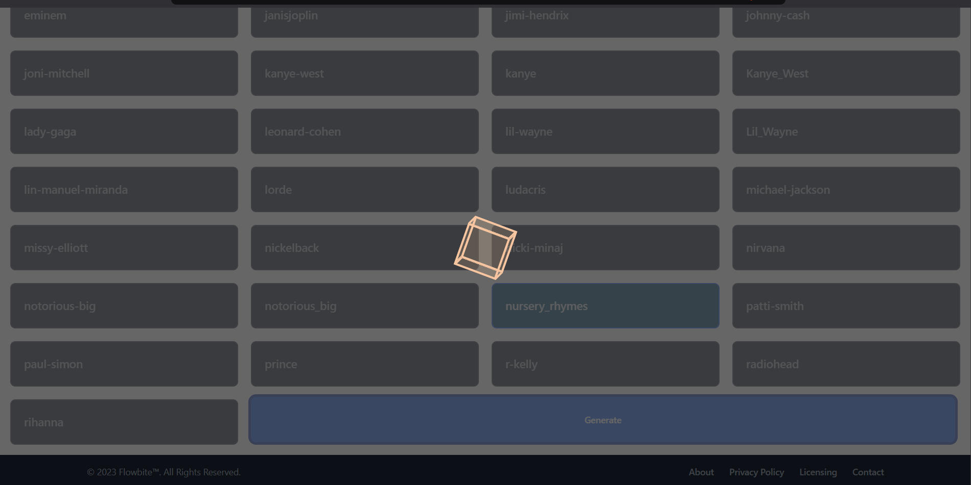**

**In the Server side the AI is Generating the Lyrics   
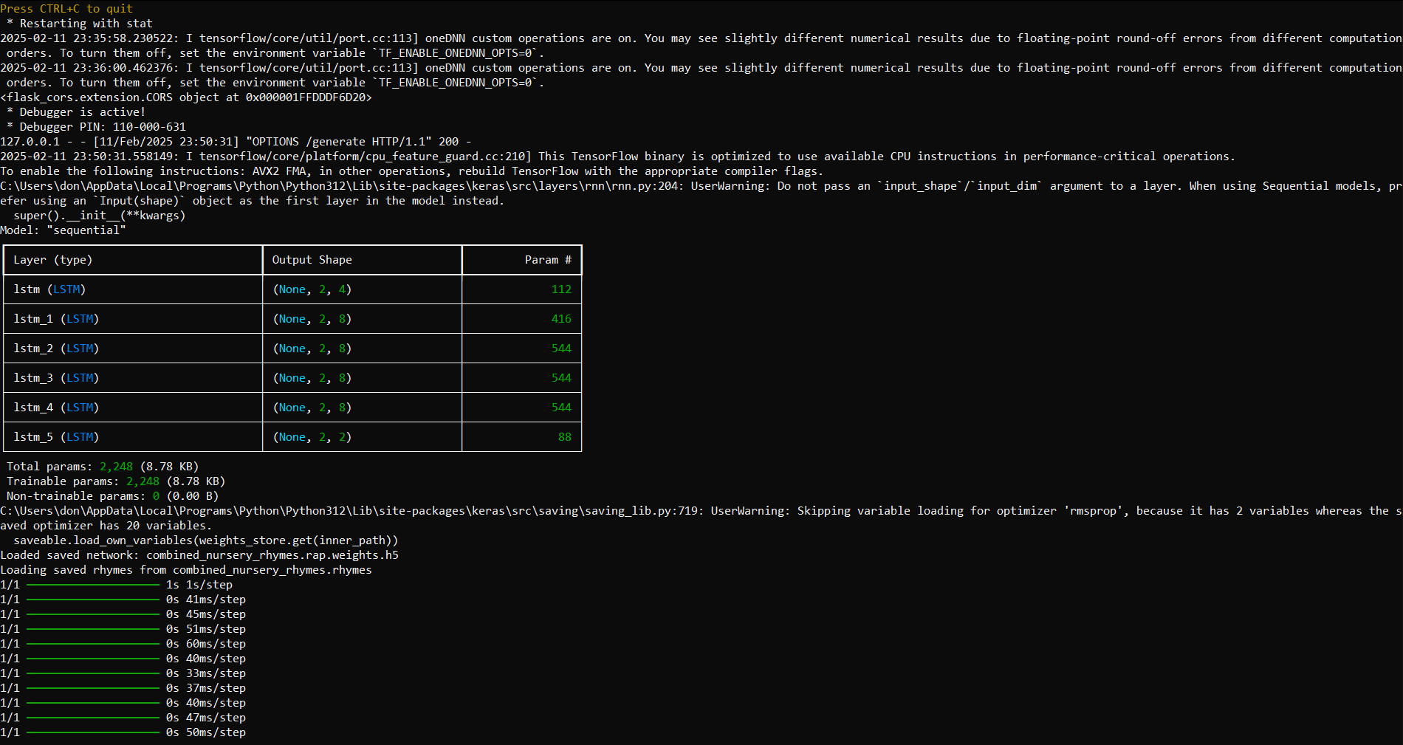**

**After the Generating phase the lyrics sent to the browser and here in the front end we got lyrics:** here you can save the lyrics by clicking on save button

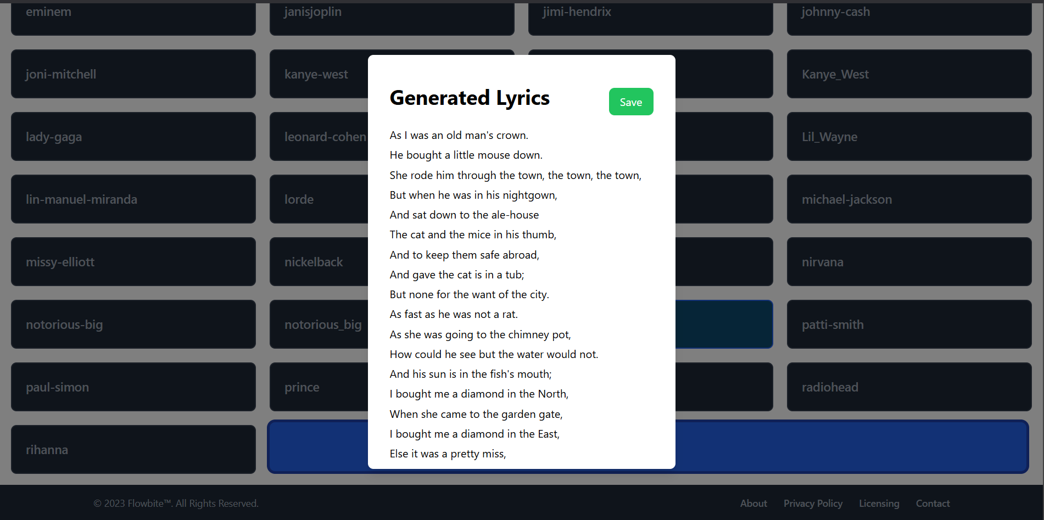

**CHAPTER 5**

**Discussion and Conclusion**

#### **5.1 Key Findings**

1. **Successful Implementation of a Lyrics Generation System:** The project successfully implemented a lyrics generation system capable of generating song lyrics based on user-selected artists. It demonstrated the ability to train models dynamically or use pre-trained models, depending on the availability.
2. **Dynamic Training for Flexibility:** The system showcased flexibility by dynamically training a model if a pre-trained model for the selected artist(s) or combination was not available. This ensures that users can generate lyrics even for less commonly selected artists.
3. **Efficient Use of Text Files for Training Data:** Instead of using a traditional database, the project leveraged text files for storing artist data. This approach simplified the data-handling process while meeting the system's requirements effectively.
4. **Fast and Accurate Lyrics Generation:** The backend was optimized to provide fast results, ensuring users do not experience significant delays, regardless of whether the lyrics were generated using a pre-trained or newly trained model.
5. **User-Friendly Frontend Interface:** The React.js-based frontend provided a clean and intuitive interface, allowing users to easily select artists and receive generated lyrics with minimal effort.
6. **Scalability of the System:** The project structure supports scalability, allowing the addition of more artists or training data without significant modifications to the codebase.
7. **Real-Time Collaboration:** The integration of Flask and React.js enabled smooth communication between the frontend and backend, ensuring a seamless user experience.
8. **Combination-Based Lyrics Generation:** The system allowed users to select combinations of multiple artists, broadening the scope of creativity and providing unique lyrics influenced by diverse styles.

These findings reflect the system's success in achieving its objectives while offering a foundation for future enhancements and scalability. Would you like to dive into 5.2 (Challenges) or expand this section?

### **5.4 Limitations**

1. **Dependence on Text File Data:**The system relies solely on text files for training data, which can limit scalability and flexibility. Managing large datasets or updating artist-specific data may become cumbersome without a structured database.
2. **Time-Intensive Model Training:**For artist combinations without a pre-trained model, the system requires real-time training, which can take a significant amount of time depending on the dataset size and computational resources. This may lead to delays in delivering results to users.
3. **Limited Generalization:**The model's quality is directly tied to the quality and diversity of the training data. If the training data is insufficient or unbalanced, the generated lyrics may lack creativity or coherence.
4. **Scalability Issues with Growing Artist List:**As the number of artists (and combinations) increases, maintaining and managing pre-trained models becomes challenging. Storing and retrieving models for combinations of 34–35 artists can consume considerable storage and memory.
5. **No Real-Time Feedback:**The system does not provide real-time feedback on the quality of generated lyrics or allow users to fine-tune the output according to their preferences.
6. **Lack of Contextual Understanding:**While the model generates lyrics based on patterns in the training data, it lacks true contextual understanding, leading to repetitive or nonsensical lines in some cases.
7. **Computational Resource Dependency:**The system's performance depends heavily on the computational power of the backend server. Limited resources can lead to slower training times and less efficient lyrics generation.
8. **Frontend Interaction Constraints:**The current frontend interface allows users to select artists but does not offer advanced customization options, such as specifying the mood, theme, or style of the lyrics.
9. **Absence of Multi-Language Support:**The system is currently limited to generating lyrics in one language (assumed to be English). This restricts its applicability for users interested in lyrics in other languages.
10. **No Collaborative or Interactive Features:**The system is designed as a single-user experience. It does not allow for collaborative lyric generation or user interaction with the generated output.

### 

### **5.5 Future Work**

1. **Integration of a Structured Database:** Replacing the text file system with a structured database (e.g., MySQL, MongoDB) can improve scalability, data management, and accessibility. This will make it easier to store and retrieve artist data, training datasets, and pre-trained models efficiently.
2. **Pre-Training for Common Combinations:** To reduce real-time training time, frequently selected artist combinations can be pre-trained in advance and stored in a database. This will significantly enhance user experience by providing faster results.
3. **Optimization of Training Algorithms:** Exploring more efficient training algorithms or pre-trained embeddings can help reduce training time without compromising the quality of generated lyrics. Techniques such as transfer learning or fine-tuning larger language models could be considered.
4. **Enhanced Frontend Features:** Adding advanced customization options in the frontend, such as mood, theme, or genre selection, can make the system more interactive and versatile for users.
5. **Incorporation of Real-Time Feedback:** Implementing a feedback mechanism where users can rate generated lyrics or provide suggestions will help improve the model's outputs and align with user preferences over time.
6. **Multi-Language Support:** Expanding the model to support multiple languages will widen its applicability to a global audience. This could involve training the model on multilingual datasets or using translation APIs.
7. **Implementation of Collaborative Features:** Introducing features for collaborative lyric generation, where multiple users can work on a single piece, can make the platform more engaging and social.
8. **Contextual Understanding Through NLP:** Incorporating more advanced natural language processing (NLP) techniques will enhance the contextual understanding of the model. This can reduce repetitive or irrelevant outputs and improve the coherence of generated lyrics.
9. **Scalability and Cloud Deployment:** Deploying the system on cloud platforms (e.g., AWS, Google Cloud) can provide better scalability and allow handling of higher user traffic while ensuring faster processing and storage efficiency.
10. **Support for Audio Integration:** Extending the system to not only generate lyrics but also convert them into music tracks (using text-to-music generation models or synthesizers) can create a more immersive experience.
11. **Integration of Artist Trends and Popularity:** Incorporating real-time trends or popular artist data from social media or music platforms can make the generated lyrics more relevant and appealing to users.
12. **Improved User Interface and Experience:** Designing a more intuitive and visually appealing frontend with live previews, suggestions, or step-by-step guidance can enhance the overall user experience.
13. **Exploration of Advanced Models:** Using advanced models like GPT-4 or other generative AI frameworks for lyrics generation can boost creativity and performance, offering more diverse and high-quality results.
14. **Model Fine-Tuning for Creativity:** Future iterations of the model can focus on improving its ability to generate unique, creative, and artistically meaningful lyrics rather than repetitive patterns.
15. **Accessibility Features:** Adding accessibility options such as voice input, screen reader support, and adaptable font sizes can make the system more user-friendly for a diverse audience.

By addressing these areas, the system can evolve into a more robust, scalable, and user-centric platform for generating high-quality lyrics efficiently.

### **5.6 Conclusion**

The **Lyrics Generator Project** successfully demonstrates the potential of AI-driven technologies in the creative domain of lyric writing. By leveraging machine learning techniques, the system offers a dynamic and user-friendly platform where users can generate unique and personalized lyrics by simply selecting their favorite artists. The use of text-based training data and a combination of pre-trained and on-demand training models highlights the adaptability and practicality of the system.

This project bridges the gap between technology and creativity, empowering users—whether musicians, writers, or enthusiasts—with a tool that simplifies and enhances the lyric creation process. Despite its limitations, such as reliance on text files and training time for new combinations, the model provides a strong foundation for further innovations in this field.

The overall contribution of this project lies in its ability to make lyric writing accessible, efficient, and customizable, paving the way for integrating artificial intelligence into artistic and creative processes. By focusing on user preferences and real-time interactions, it successfully aligns technical advancements with creative aspirations, making it a valuable tool for the music and entertainment industries.

Future enhancements, such as database integration, multi-language support, and advanced training techniques, can further extend the scope and impact of this project. In conclusion, the Lyrics Generator Project stands as a testament to how artificial intelligence can enhance human creativity, offering endless possibilities for exploration and innovation in the world of music and beyond.

**REFERENCES**

1. **Flask Documentation** – Official Flask documentation for building web applications.  
   * 🔗<https://flask.palletsprojects.com/>
2. **React.js Documentation** – Official guide for building frontend applications using React.  
   * 🔗<https://react.dev/>
3. **Natural Language Processing (NLP) Resources** – Guides on training models for text generation.  
   * 🔗<https://www.nltk.org/> (NLTK - Natural Language Toolkit)
   * 🔗<https://huggingface.co/> (Hugging Face - Transformers for NLP)
4. **Text Generation Using Deep Learning** – Research papers on text generation techniques.  
   * Radford, A., Wu, J., Child, R., Luan, D., Amodei, D., & Sutskever, I. (2019). *Language Models are Few-Shot Learners*. OpenAI.
   * Hochreiter, S., & Schmidhuber, J. (1997). *Long Short-Term Memory*. Neural Computation, 9(8), 1735–1780.
5. **Python Libraries for Deep Learning**
   * TensorFlow:<https://www.tensorflow.org/>
   * PyTorch:<https://pytorch.org/>
6. **Handling Large Text Files in Python**
   * 🔗<https://realpython.com/read-write-files-python/>
7. **GitHub Repositories with Similar Projects**
   * Example:<https://github.com/minimaxir/textgenrnn>